 **INTERNSHIP BATCH 2022 (ORACLE APPS)**

**BATCH-2**

**HOSPITAL MANAGEMENT SYSTEM PROJECT**

MENTOR: WILLIAM LAWRENCE

TEAM MEMBERS

1. Kuruba Akhil
2. Shadab Salim Mulla
3. Koyena Chakraborty
4. Prajwal
5. Bapusaheb Patil
6. Sv Sai Subhash
7. Selvan senthil
8. Devi VaraPrasad
9. Roopasri Pokuri

**CONTENTS :**

* AIM
* OBJECTIVE
* REPORT

**AIM**

* This software helps in handling the patients admissions with great ease.
* Allows hospitals to add their bills, bed charges, arrange the admission dates and discharge patients without any fuss.

**OBJECTIVE**

* Provide MIS (Management Information System) report on demand to management for better decision making.
* Design a system for better patient care. Reduce hospital operating costs.
* This is indeed the best dedicated software for improving the functioning for Clinics, Hospitals and Doctors

**ASSUMPTION:**

* This design assumes that the following statements are true: •
* List of Patients given by the customer will not change very frequently as this contains pre-created list of patients •

* Penalties are calculated on Indian Rupees as the software is assumed to be used only in India

**SOFTWARE REQUIREMENT**

1. Oracle Forms 10g
2. Oracle Reports 10g.
3. Oracle Database Server 11g

CREATE TABLE PATIENT_MASTER_TEAM2(PATIENT_ID NUMBER(10) PRIMARY KEY,PATIENT_NAME VARCHAR2(30),BLOOD_GROUP VARCHAR2(3),DATE_OF_FIRST_VISIT DATE,AGE NUMBER(3),GENDER CHAR(1),SENIOR_CITIZEN CHAR(1),CREATION_DATE DATE,CREATED_BY NUMBER(15),LAST_UPDATE_DATE DATE,LAST_UPDATED_BY NUMBER(15),LAST_UPDATE_LOGIN NUMBER(15));

------------------------------------------------------------------------------------------------------------------------------------------------------

CREATE TABLE CONTACT_DETAILS_TEAM2(PATIENT_ID NUMBER(10), MOBILE VARCHAR2(15), HOME VARCHAR2(15), ADDRESS VARCHAR2(50), CITY_PIN VARCHAR2(20),FOREIGN KEY(PATIENT_ID) REFERENCES PATIENT_MASTER_TEAM2(PATIENT_ID) );

------------------------------------------------------------------------------------------------------------------------------------------------------

CREATE TABLE PATIENT_HISTORY_TEAM2(BILL_NUMBER NUMBER(10) PRIMARY KEY,PATIENT_ID NUMBER(10),STATUS_CODE VARCHAR2(1),ATTENDER_NAME VARCHAR2(30),VISIT_NUMBER NUMBER(4),SYMPTOM_ISSUE VARCHAR2(50),CONSULTED_DR VARCHAR2(30),DIAGNOSIS VARCHAR2(50),ADMITTED_DATE DATE,DISCHARGED_DATE DATE,BILL_AMOUNT NUMBER(9,2),CREATION_DATE DATE,CREATED_BY NUMBER(15),LAST_UPDATE_DATE DATE,LAST_UPDATED_BY NUMBER(15),LAST_UPDATE_LOGIN NUMBER(15), FOREIGN KEY(PATIENT_ID) REFERENCES PATIENT_MASTER_TEAM2(PATIENT_ID) );

==========================================================

GRANT ALL ON PATIENT_MASTER_TEAM2 TO apps;

GRANT ALL ON CONTACT_DETAILS_TEAM2 TO apps;

GRANT ALL ON PATIENT_HISTORY_TEAM2 TO apps;

=========================================================

CREATE SYNONYM PATIENT_HISTORY_TEAM2 FOR hr.PATIENT_MASTER_TEAM2;

CREATE SYNONYMPATIENT_MASTER_TEAM2 FOR hr.PATIENT_MASTER_TEAM2;

CREATE SYNONYM CONTACT_DETAILS_TEAM2 FOR hr.CONTACT_DETAILS_TEAM2;

==================================================================================================

**FORM:**

**------------------**

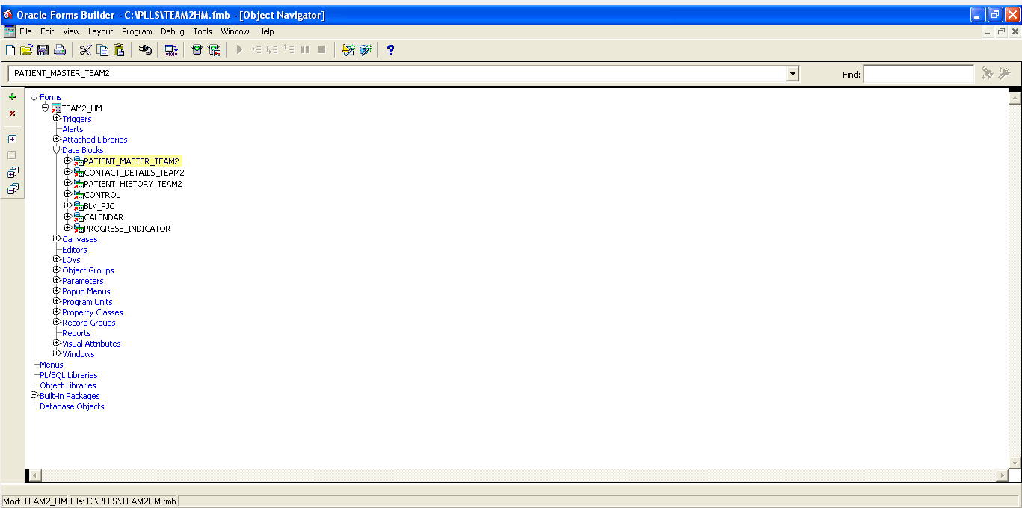

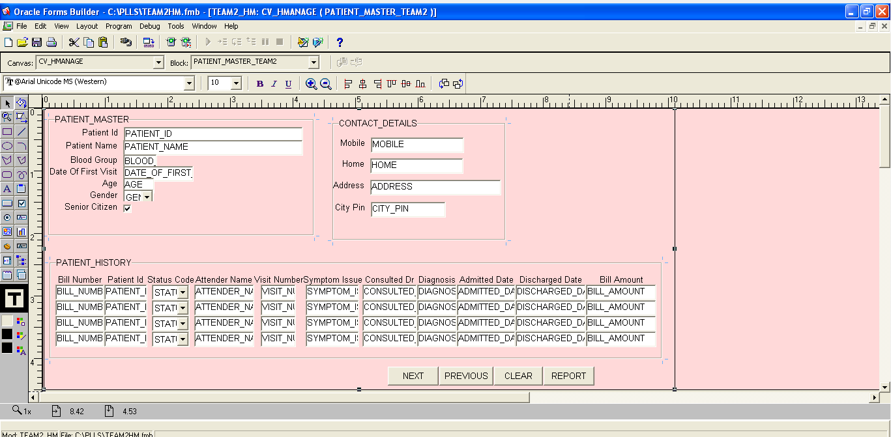

SEQUENCE:

PATIENT ID:

SELECT PATIENT_ID_TE2.NEXTVAL INTO :PATIENT_MASTER_TEAM2.PATIENT_ID FROM DUAL;

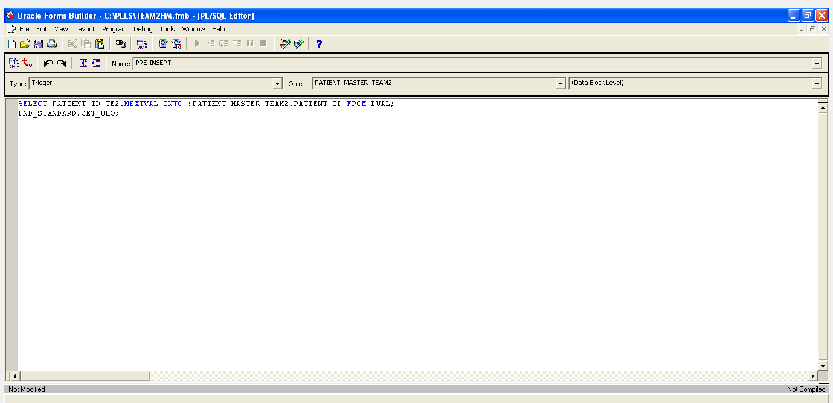

-------------------------------------------------------------

AGE:

IF :PATIENT_MASTER_TEAM2_.AGE >=65 THEN

:PATIENT_MASTER_TEAM2_.SENIOR_CITIZEN := 'Y';

ELSIF :PATIENT_MASTER_TEAM2.AGE <65 THEN

:PATIENT_MASTER_TEAM2.SENIOR_CITIZEN := 'N';

END IF;

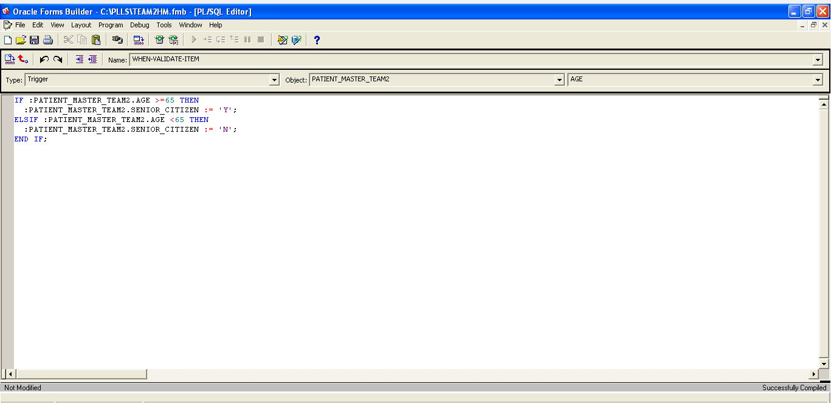

--------------------------------------------------------------------------

STATUS CODE:

IF :PATIENT_HISTORY_TEAM2.STATUS_CODE='O' THEN

:PATIENT_HISTORY_TEAM2_.ADMITTED_DATE :=NULL;

:PATIENT_HISTORY_TEAM2_.DISCHARGED_DATE :=NULL;

SET_ITEM_PROPERTY('PATIENT_HISTORY_TEAM2.ADMITTED_DATE',ENABLED,PROPERTY_FALSE);

SET_ITEM_PROPERTY('PATIENT_HISTORY_TEAM2.DISCHARGED_DATE',ENABLED,PROPERTY_FALSE);

ELSIF :PATIENT_HISTORY_TEAM2.STATUS_CODE='I' THEN

:PATIENT_HISTORY_TEAM2.ADMITTED_DATE := SYSDATE;

SET_ITEM_PROPERTY('PATIENT_HISTORY_TEAM2.ADMITTED_DATE',ENABLED,PROPERTY_TRUE);

SET_ITEM_PROPERTY('PATIENT_HISTORY_TEAM2.DISCHARGED_DATE',ENABLED,PROPERTY_TRUE);

END IF;

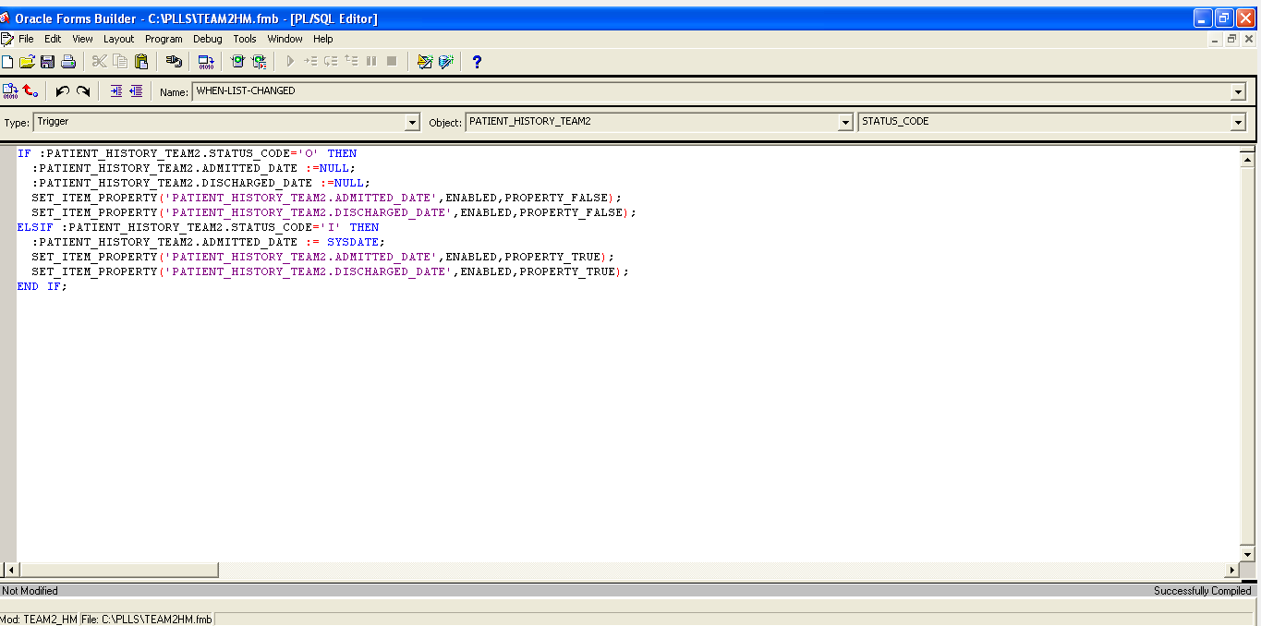

**FOR GETTING WHO COLUMNS:**

PRE-INSERT:FND_STANDARD.SET_WHO;



PRE-UPDATE:FND_STANDARD.SET_WHO;

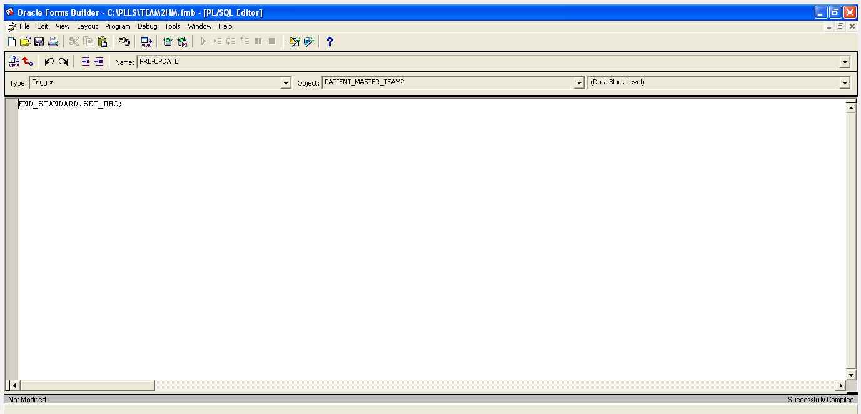

------------------------------------------------------------------------------------

**FORMS UPLOADING:**

-----------------

pwd

ls

. APPSPROD_ebs.env

cd $AU_TOp/forms/US

pwd

UPLOAD THE FORM USING LOCATION

ls TEAM2HM.fmb

NOW WE WANT TO GENERATE A .fmx FILE FOR OUR FORM.

frmcmp_batch userid=apps/apps MODULE_TYPE=form MODULE=TEAM2HM.fmb

.fmx FILE WILL BE GENERATED

mv TEAM2HM.fmx $PER_TOP/forms/US

ls TEAM2HM.fmx

---------------------------------------------------------------------------

**REPORTS:**

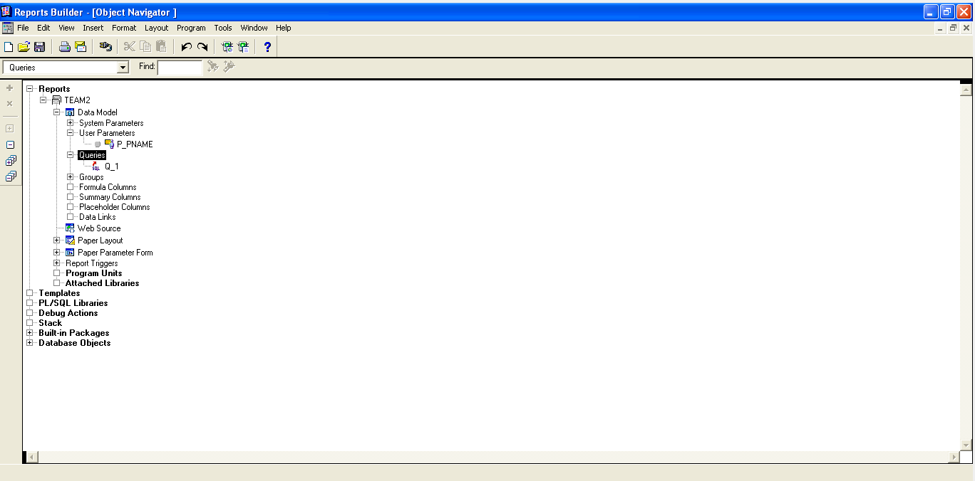

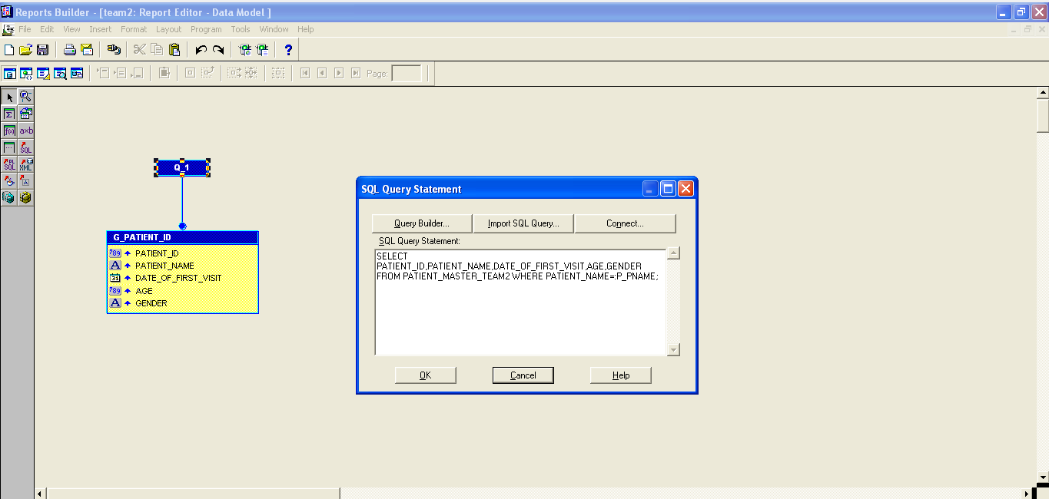

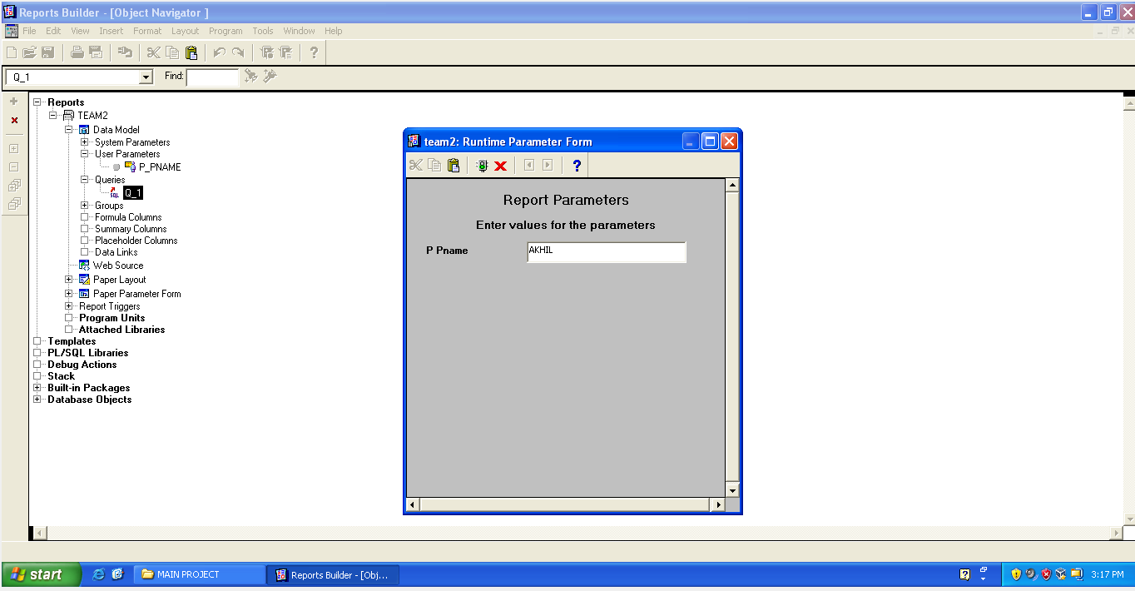

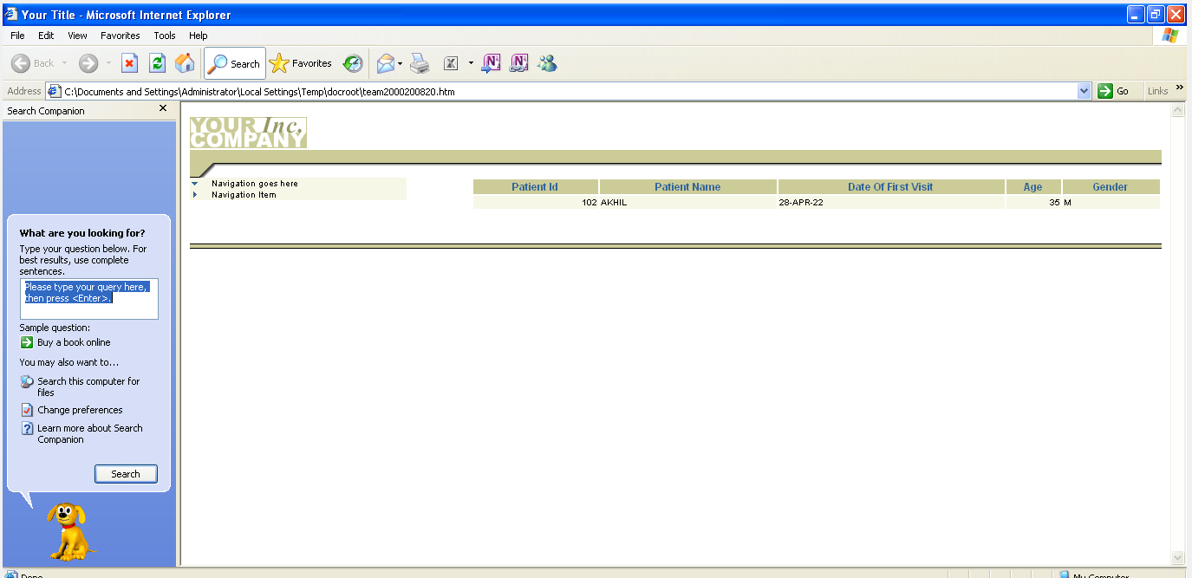

**------------------------------------------------**

**ORACLE APPS DETAILS LOGIN DETAILS:**

Application User: INTN2022FEB21TEAM2

Password: 654321

=================================================

Form Name: TEAM2HM

Function Name: TEAM2_HM_F1

-------------------

SUB MENU: SUB_MENU_TEAM2

PARENT MENU: PARENT_MENU_TEAM2

RESPONSIBILITY NAME: RESPONSIBILITY_TEAM2

Request Group: RG_TEAM2

----------------------------

Registering Form: R _TEAM_2

Concurrent Program For Procedure: CP_TEAM2_PRO

Value Set: ACTION_T2

-----------------------------

Registering Report: REG_TEAM2

Concurrent Program For Report: CP_TEAM2

------------------------------------------------------------------------------------

**ORACLE FORM:**

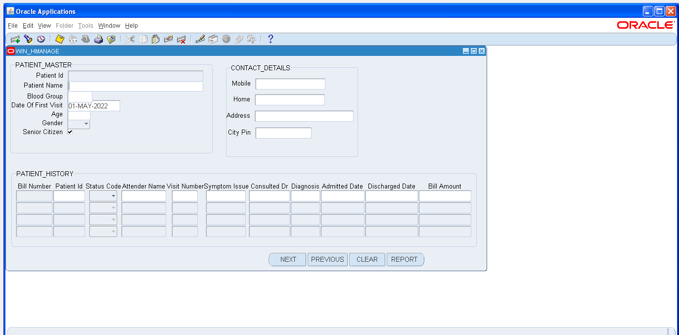

**VALUE SETS:**

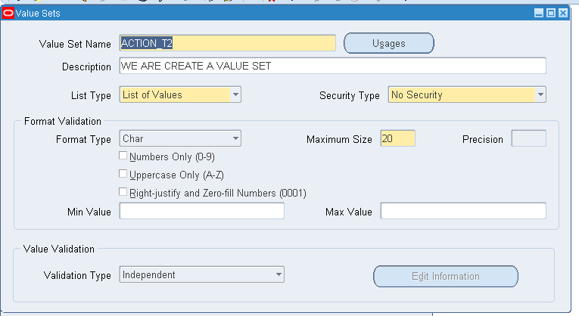

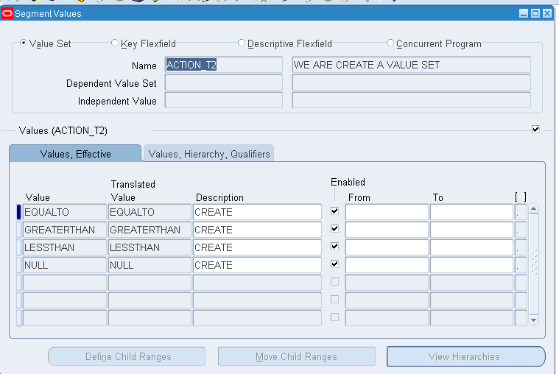

**------------------------------------------------**

**CONCURRENT PROGRAM FOR**

**REPORT:**

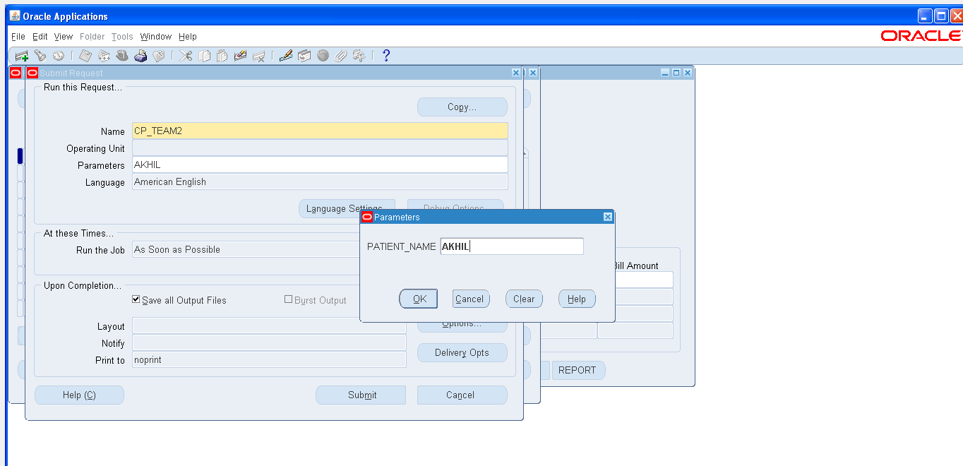

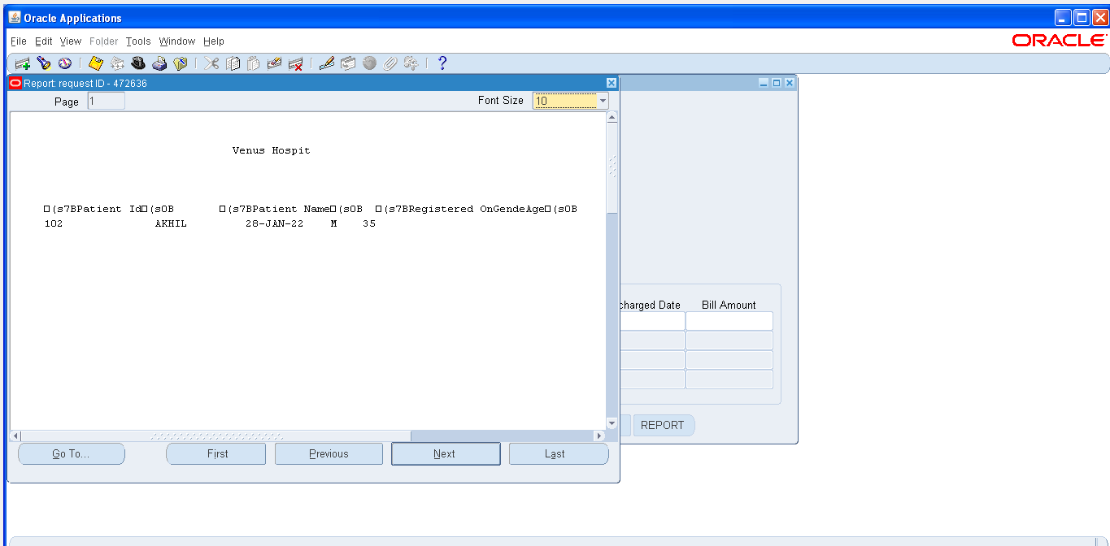

------------------------------

**CONCURRENT PROGRAM FOR PROCEDURE:**

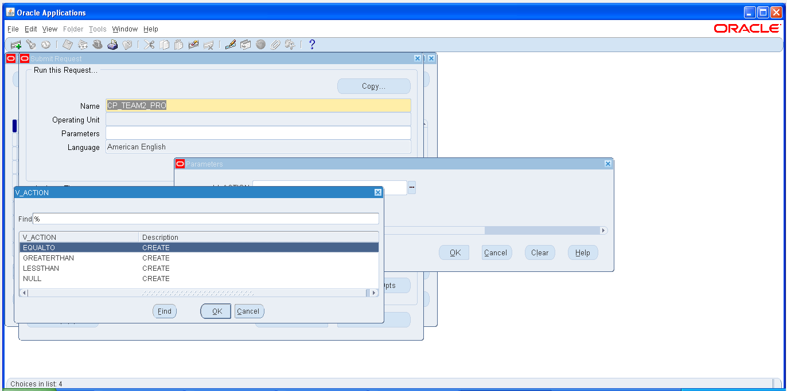

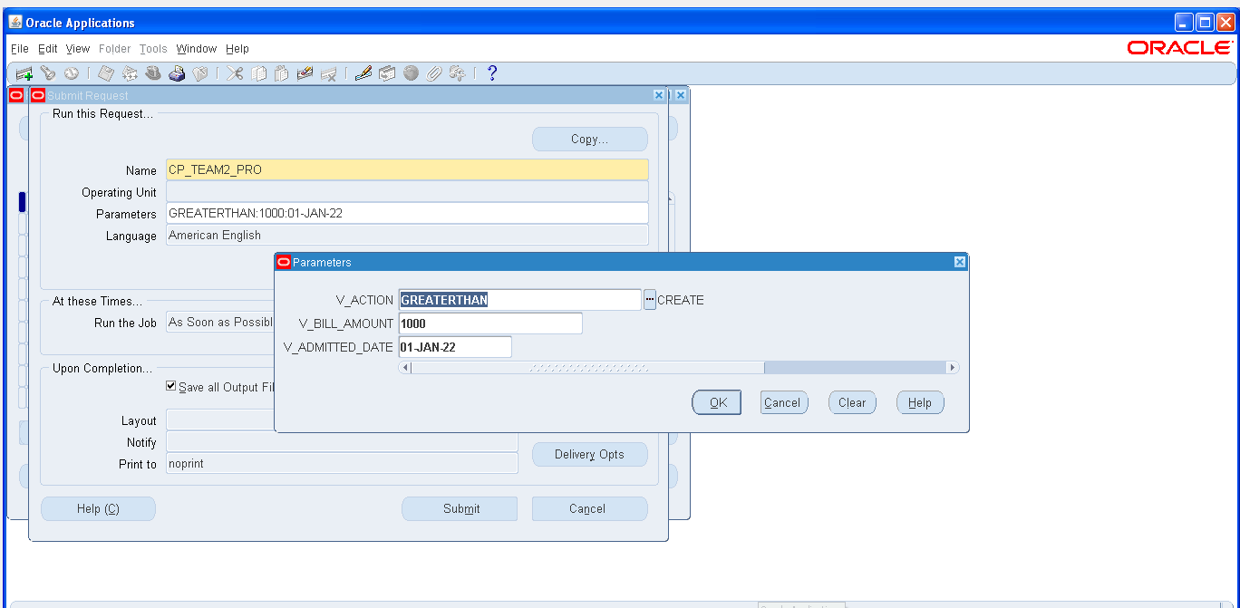

CREATE OR REPLACE PROCEDURE PROG_TEAM2(V_ERRCODE OUT NUMBER,V_ERRMSG OUT VARCHAR2,V_ACTION VARCHAR2,V_BILL_AMOUNT PATIENT_HISTORY_TEAM2.BILL_AMOUNT%TYPE,V_ADMITTED_DATE PATIENT_HISTORY_TEAM2.ADMITTED_DATE%TYPE)

IS

V_PID NUMBER(10);

V_PNAME VARCHAR2(30);

V_SYMPTOM VARCHAR2(50);

V_DOCTOR VARCHAR2(30);

V_DIA VARCHAR2(50);

V_BAMOUNT NUMBER(9,2);

CURSOR V_C1 IS SELECT * FROM PATIENT_HISTORY_TEAM2 FOR UPDATE NOWAIT;

BEGIN

FOR V_REC IN V_C1 LOOP

IF V_ACTION='GREATERTHAN' THEN

IF V_REC.BILL_AMOUNT>V_BILL_AMOUNT AND V_REC.ADMITTED_DATE>V_ADMITTED_DATE THEN

SELECT PATIENT_NAME INTO V_PNAME FROM PATIENT_MASTER_TEAM2 WHERE PATIENT_ID=V_REC.PATIENT_ID;

SELECT V_REC.PATIENT_ID,V_REC.SYMPTOM_ISSUE,V_REC.CONSULTED_DR,V_REC.DIAGNOSIS,V_REC.BILL_AMOUNT INTO V_PID,V_SYMPTOM,V_DOCTOR,V_DIA,V_BAMOUNT FROM PATIENT_HISTORY_TEAM2 WHERE PATIENT_ID=V_REC.PATIENT_ID;

DBMS_OUTPUT.PUT_LINE('RECORD FIND IN GIVEN OBJECT GREATERTHAN');

FND_FILE.PUT_LINE(FND_FILE.OUTPUT,'RECORD IN THE TABLES');

FND_FILE.PUT_LINE(FND_FILE.OUTPUT,V_PID);

FND_FILE.PUT_LINE(FND_FILE.OUTPUT,V_PNAME);

FND_FILE.PUT_LINE(FND_FILE.OUTPUT,V_SYMPTOM);

FND_FILE.PUT_LINE(FND_FILE.OUTPUT,V_DOCTOR);

FND_FILE.PUT_LINE(FND_FILE.OUTPUT,V_DIA);

FND_FILE.PUT_LINE(FND_FILE.OUTPUT,V_BAMOUNT);

END IF;

ELSIF V_ACTION='LESSTHAN' THEN

IF V_REC.BILL_AMOUNT<V_BILL_AMOUNT AND V_REC.ADMITTED_DATE<V_ADMITTED_DATE THEN

SELECT PATIENT_NAME INTO V_PNAME FROM PATIENT_MASTER_TEAM2 WHERE PATIENT_ID=V_REC.PATIENT_ID;

SELECT V_REC.PATIENT_ID,V_REC.SYMPTOM_ISSUE,V_REC.CONSULTED_DR,V_REC.DIAGNOSIS,V_REC.BILL_AMOUNT INTO V_PID,V_SYMPTOM,V_DOCTOR,V_DIA,V_BAMOUNT FROM PATIENT_HISTORY_TEAM2 WHERE PATIENT_ID=V_REC.PATIENT_ID;

DBMS_OUTPUT.PUT_LINE('RECORD FIND IN GIVEN OBJECT LESSTHAN');

FND_FILE.PUT_LINE(FND_FILE.OUTPUT,'RECORD IN THE TABLES');

FND_FILE.PUT_LINE(FND_FILE.OUTPUT,V_PID);

FND_FILE.PUT_LINE(FND_FILE.OUTPUT,V_PNAME);

FND_FILE.PUT_LINE(FND_FILE.OUTPUT,V_SYMPTOM);

FND_FILE.PUT_LINE(FND_FILE.OUTPUT,V_DOCTOR);

FND_FILE.PUT_LINE(FND_FILE.OUTPUT,V_DIA);

FND_FILE.PUT_LINE(FND_FILE.OUTPUT,V_BAMOUNT);

END IF;

ELSIF V_ACTION='EQUALTO' THEN

IF V_REC.BILL_AMOUNT=V_BILL_AMOUNT AND V_REC.ADMITTED_DATE=V_ADMITTED_DATE THEN

SELECT PATIENT_NAME INTO V_PNAME FROM PATIENT_MASTER_TEAM2 WHERE PATIENT_ID=V_REC.PATIENT_ID;

SELECT V_REC.PATIENT_ID,V_REC.SYMPTOM_ISSUE,V_REC.CONSULTED_DR,V_REC.DIAGNOSIS,V_REC.BILL_AMOUNT INTO V_PID,V_SYMPTOM,V_DOCTOR,V_DIA,V_BAMOUNT FROM PATIENT_HISTORY_TEAM2 WHERE PATIENT_ID=V_REC.PATIENT_ID;

DBMS_OUTPUT.PUT_LINE('RECORD FIND IN GIVEN OBJECT EQUAL');

FND_FILE.PUT_LINE(FND_FILE.OUTPUT,'RECORD IN THE TABLES');

FND_FILE.PUT_LINE(FND_FILE.OUTPUT,V_PID);

FND_FILE.PUT_LINE(FND_FILE.OUTPUT,V_PNAME);

FND_FILE.PUT_LINE(FND_FILE.OUTPUT,V_SYMPTOM);

FND_FILE.PUT_LINE(FND_FILE.OUTPUT,V_DOCTOR);

FND_FILE.PUT_LINE(FND_FILE.OUTPUT,V_DIA);

FND_FILE.PUT_LINE(FND_FILE.OUTPUT,V_BAMOUNT);

END IF;

ELSIF V_ACTION='NULL' THEN

SELECT PATIENT_NAME INTO V_PNAME FROM PATIENT_MASTER_TEAM2 WHERE PATIENT_ID=V_REC.PATIENT_ID;

SELECT V_REC.PATIENT_ID,V_REC.SYMPTOM_ISSUE,V_REC.CONSULTED_DR,V_REC.DIAGNOSIS,V_REC.BILL_AMOUNT INTO V_PID,V_SYMPTOM,V_DOCTOR,V_DIA,V_BAMOUNT FROM PATIENT_HISTORY_TEAM2 WHERE PATIENT_ID=V_REC.PATIENT_ID;

DBMS_OUTPUT.PUT_LINE('RECORD FIND IN GIVEN OBJECT NULL');

FND_FILE.PUT_LINE(FND_FILE.OUTPUT,'RECORD IN THE TABLES');

FND_FILE.PUT_LINE(FND_FILE.OUTPUT,V_PID);

FND_FILE.PUT_LINE(FND_FILE.OUTPUT,V_PNAME);

FND_FILE.PUT_LINE(FND_FILE.OUTPUT,V_SYMPTOM);

FND_FILE.PUT_LINE(FND_FILE.OUTPUT,V_DOCTOR);

FND_FILE.PUT_LINE(FND_FILE.OUTPUT,V_DIA);

FND_FILE.PUT_LINE(FND_FILE.OUTPUT,V_BAMOUNT);

END IF;

END LOOP;

COMMIT;

END;

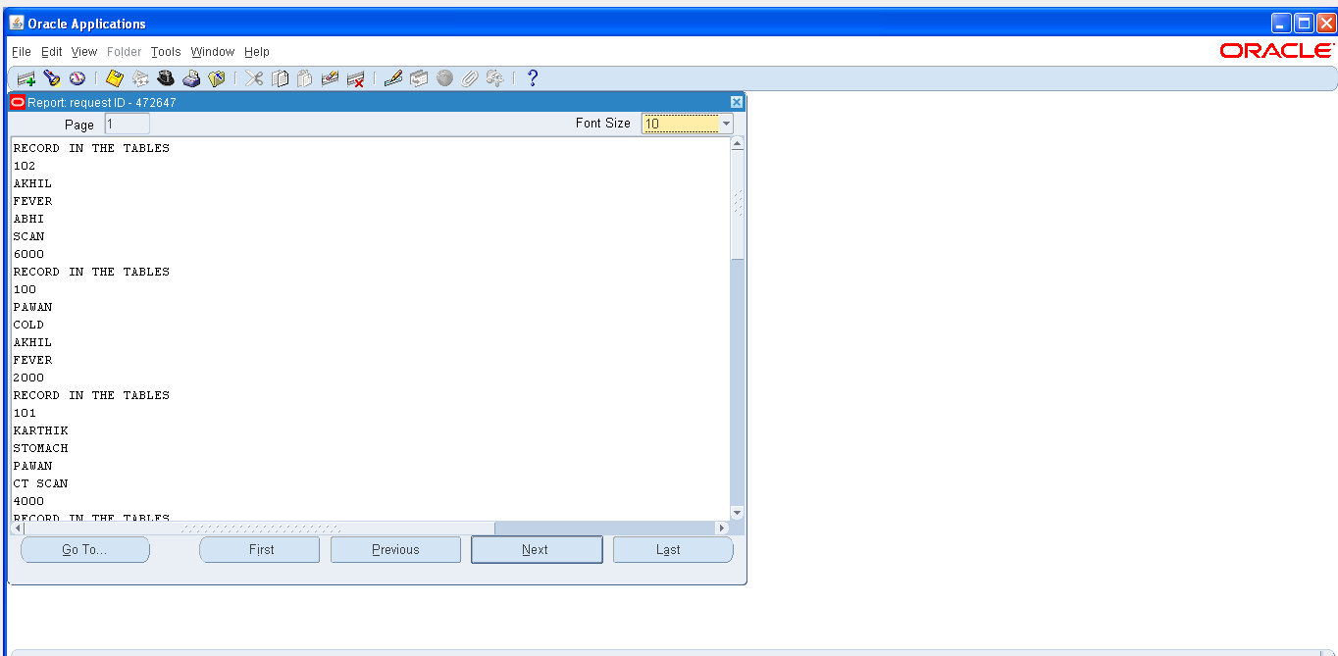

**THANK YOU**